## Mini-Project: Plan for Analysis

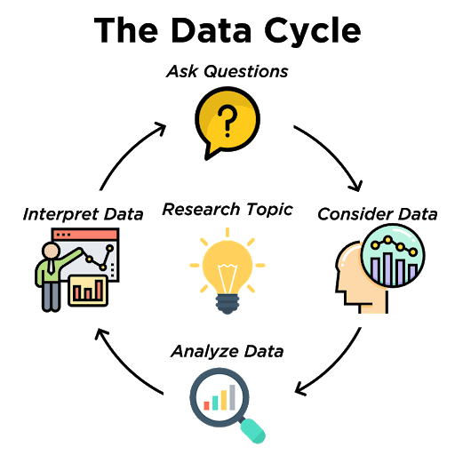

In this lesson, you won’t analyze the data quite yet but planning your analysis is important.

**Task:**

Answer the following questions with sufficient detail.

1. What columns will you need to use to answer your question? How will you use them?
2. What calculations might you need to make?
3. What visualization (like a chart or graph) might be able to help? Why would it be helpful?